*This job aide demonstrates how to find and correct missed punches for employees in Dimensions.*

**Notes**

* Missed punches are considered an Exception in Dimensions.
* Missed punches must be fixed before approving / signing off on an employee’s timecard.
* Missed punches directly affect an employee’s pay, resulting in over or under payment to the employee.
* An employee must complete the Exceptions Log with the correct missed punch time and sign. Once complete, the punch time can be entered into Dimensions.

**Missed Punches**

1. The Manage Timecards tile on the home screen indicates if there are missing punches for the pay period displayed in the tile.
   1. In the example below, there are 3 missed out punches and 1 missed in punch for the current pay period.
2. Click on the arrow in the Must Fix area.
   1. Dimensions will open the timecard for each employee with a missed punch.

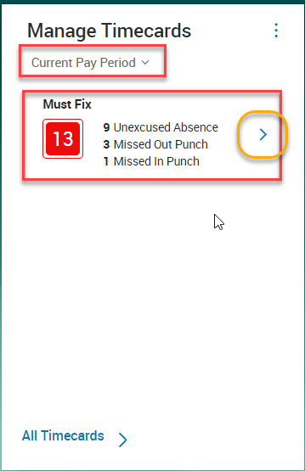

1. To correct timecard, click in the red box and enter the time employee clocked in or out.



1. Right click on the time entered, click Comments. Add the appropriate comment. Click Apply

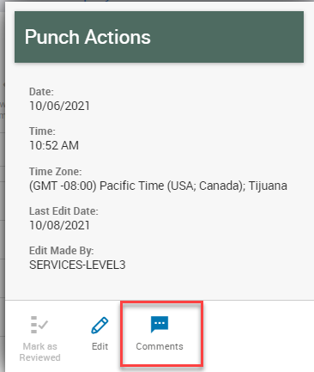 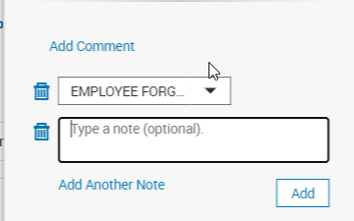

1. Timecard will now reflect the correct time.



1. Click Save